Insert your name, centre number and candidate number into the header above.
Save this evidence document as evidence_ followed by your centre number_ candidate number. For example: evidence_ zz999_9999.doc
Screenshots or program listings must be copied into appropriate cells in the following tables.
Examiners must be able to read the contents including any screenshots without the use of a magnifying glass. Answers that are not readable or missing will not be awarded any marks.
Save this evidence document at regular intervals, for example, every 10 minutes.
Question 1
Part 1(a)
{Copy and paste program code listing for question 1(a) here}

global Stack # DECLARE Stack: ARRAY[0:19] OF STRING
global TopOfStack # DECLARE TopOfStack: INTEGER

#main
Stack=["-1" for _ in range(20)]
TopOfStack=-1

Part 1(b)
{Copy and paste program code listing for question 1(b) here}

global Stack # DECLARE Stack: ARRAY[0:19] OF STRING
global TopOfStack # DECLARE TopOfStack: INTEGER

def Push(Data):
global Stack
global TopOfStack

if TopOfStack+1>=20:
return -1

TopOfStack+=1
Stack[TopOfStack]=Data
return 1

Part 1(c)
{Copy and paste program code listing for question 1(c) here}

def Pop():
global Stack
global TopOfStack
if TopOfStack<0:
return "-1"
TopOfStack-=1
return Stack[TopOfStack+1]

Part 1(d)
{Copy and paste program code listing for question 1(d) here}

def ReadData(FileName):
try:
f=open(FileName, 'r')

x=f.readline().strip()
while x!="":
if Push(x)==-1:
print("Stack full")
x=f.readline().strip()
f.close()
except IOError:
print("File not found.")

Part 1(e)
{Copy and paste program code listing for question 1(e) here}

def Calculate():
Total=int(Pop())
x=Pop()
while x!="-1":
if x=="+": Total+=int(Pop())
elif x=="-": Total-=int(Pop())
elif x=="*": Total*=int(Pop())
elif x=="/": Total/=int(Pop())
elif x=="^": Total**=int(Pop())
x=Pop()
return Total

Part 1(f)(i)
{Copy and paste program code listing for question 1(f)(i) here}

FName=input("Enter a filename. ")
ReadData(FName)
print(Calculate())

Part 1(f)(ii)
{Copy and paste screenshot for question 1(f)(ii) here}

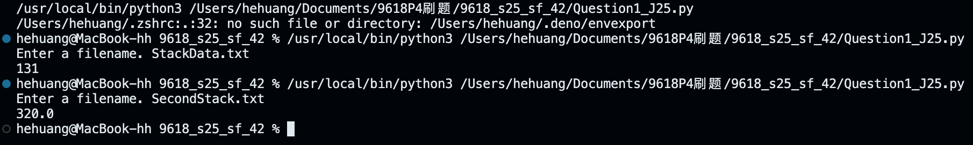

Question 2
Part 2(a)
{Copy and paste program code listing for question 2(a) here}

class NewRecord:
def __init__(self,k,i1,i2):
self.Key=k # DECLARE Keys: INTEGER
self.Item1=i1 # DECLARE Item1: INTEGER
self.Item2=i2 # DECLARE Item2: INTEGER

Part 2(b)(i)
{Copy and paste program code listing for question 2(b)(i) here}

global HashTable # DECLARE HashTable: ARRAY[0:199] OF NewRecord
global Spare # DECLARE Spare: ARRAY[0:99] OF NewRecord

#main
HashTable=[]
Spare=[]

Part 2(b)(ii)
{Copy and paste program code listing for question 2(b)(ii) here}

def Initialise():
global HashTable
global Spare
HashTable=[NewRecord(-1,-1,-1) for _ in range(200)]
Spare=[NewRecord(-1,-1,-1) for _ in range(100)]

Part 2(c)
{Copy and paste program code listing for question 2(c) here}

def CalculateHash(Key):
return Key % 200

Part 2(d)
{Copy and paste program code listing for question 2(d) here}

def InsertIntoHash(New):
global HashTable
global Spare
Index=CalculateHash(New.Key)
if HashTable[Index].Key==-1:
HashTable[Index]=New
else:
for j in range(100):
if Spare[j].Key==-1:
Spare[j]=New
break

Part 2(e)
{Copy and paste program code listing for question 2(e) here}

def CreateHashTable():
try:
f=open("HashData.txt",'r')
x=f.readline().strip()
while x!="":
y=x.split(',')
NewRec=NewRecord(int(y[0]),int(y[1]),int(y[2]))
InsertIntoHash(NewRec)
x=f.readline().strip()
f.close()
except IOError:
print("File not found.")

Part 2(f)(i)
{Copy and paste program code listing for question 2(f)(i) here}

def PrintSpare():
global Spare
for k in range(100):
if Spare[k].Key==-1: break
else: print(Spare[k].Key)

Part 2(f)(ii)
{Copy and paste program code listing for question 2(f)(ii) here}

Initialise()
CreateHashTable()
PrintSpare()

Part 2(f)(iii)
{Copy and paste screenshot for question 2(f)(iii) here}

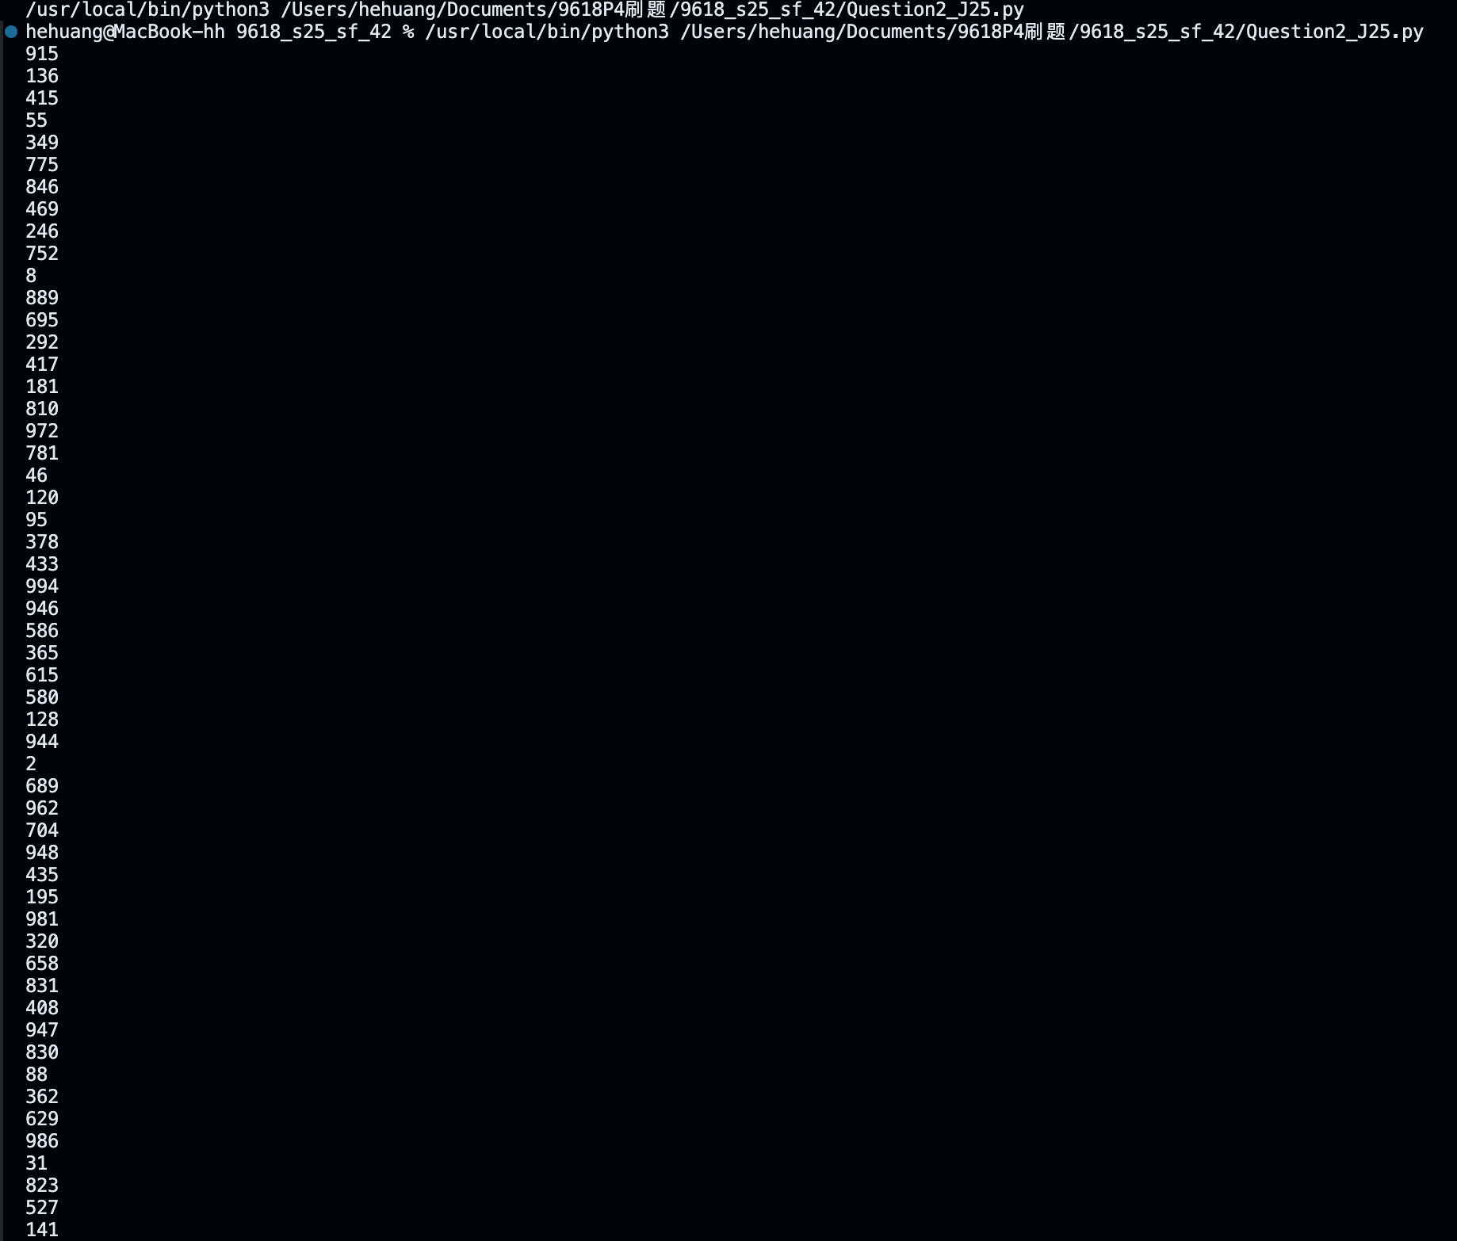

Question 3
Part 3(a)(i)
{Copy and paste program code listing for question 3(a)(i) here}

class Animal:
def __init__(self,n,sound,size,intelligence):
self.__Name=n # PRIVATE Name: STRING
self.__Sound=sound # PRIVATE Sound: STRING
self.__Size=size # PRIVATE Size: INTEGER
self.__Intelligence=intelligence # PRIVATE Intelligence: INTEGER

Part 3(a)(ii)
{Copy and paste program code listing for question 3(a)(ii) here}

def Description(self):
return f"The animal's name is {self.__Name}, it makes a {self.__Sound}, its size is {self.__Size} and its intelligence level is {self.__Intelligence}"

Part 3(b)(i)
{Copy and paste program code listing for question 3(b)(i) here}

class Parrot(Animal):
def __init__(self, n, sound, size, intelligence,w,nw):
super().__init__(n, sound, size, intelligence)
self.__WingSpan=w # PRIVATE WingSpan: INTEGER
self.__NumberWords=nw # PRIVATE NumberWords: INTEGER

def ChangeNumberWords(self, NewNum):
self.__NumberWords+=NewNum

Part 3(b)(ii)
{Copy and paste program code listing for question 3(b)(ii) here}

def Description(self):
return (super().Description()+f". It has a wingspan of {self.__WingSpan} cm and can say {self.__NumberWords} words.")

Part 3(c)(i)
{Copy and paste program code listing for question 3(c)(i) here}

class Wolf(Animal):
def __init__(self, n, sound, size, intelligence,ts):
super().__init__(n, sound, size, intelligence)
self.__TerritorySize=ts # PRIVATE TerritorySize: INTEGER

def SetTerritorySize(self,NewSize):
self.__TerritorySize+=NewSize

Part 3(c)(ii)
{Copy and paste program code listing for question 3(c)(ii) here}

def Description(self):
return super().Description()+f". Its territory is {self.__TerritorySize} square miles."

Part 3(d)(i)
{Copy and paste program code listing for question 3(d)(i) here}

#main
Parrot1=Parrot("Chewie","Squawk",1,10,30,29)
Wolf1=Wolf("NightEyes","Howl",8,7,100)
Animal1=Animal("Copper","Neigh",10,6)

Part 3(d)(ii)
{Copy and paste program code listing for question 3(d)(ii) here}

Wolf1.SetTerritorySize(-20)
Parrot1.ChangeNumberWords(2)
print(Parrot1.Description())
print(Wolf1.Description())
print(Animal1.Description())

Part 3(d)(iii)
{Copy and paste screenshot for question 3(d)(iii) here}

